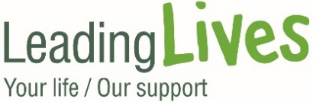

Leading Lives Community Benefit Fund 2020
Application Form

Your name

Your organisation/ group

Address

Contact email

Telephone no.

Website address

Social media account handles | Facebook:  Twitter:  Instagram:
Please confirm what sort of organisation you are (e.g. an individual, group, social enterprise, charity etc.)
If you are a registered charity, please provide your charity number
Please confirm who will take responsibility for the project confirming any job titles / roles in the organisation / group
Please confirm the timescale for the project including any fixed parameters

- Please tell us about the project you are seeking funding for, including expected outputs and anticipated outcomes for beneficiaries?

200 words max.

- Please tell us about the services or supports your organisation or group provides?

100 words max.

- Please tell us who will specifically benefit from the project and how many people this will impact?

50 words max.

- Please confirm which geographical area(s) this project will cover?

30 words max.

- Please confirm how much funding you seek and how this will be allocated? Please briefly outline how you will implement the project – e.g. what are the key stages / actions / activities?

200 words max.

- Please confirm where any other sources of funding will come from and, if this project does involve a partnership approach, please identify partners and briefly describe how it will work?

100 words max.

- Please confirm how you will publicise the project

50 words

Please return this application form to:
Sarah Laflin @ sarah.laflin@leadinglives.org.uk
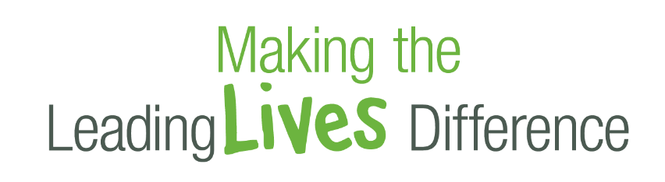
Telephone: 07521 266607 / 01473 351629

